EXPEREIMENT 5

Create a simple cloud software application for Mark Sheet Processing System using any Cloud Service Provider to demonstrate SaaS include the necessary fields such as name of the student, Reg no of the student, Subjects , Marks, Average, percentage, rank, overall performance etc.

1.create students details application form

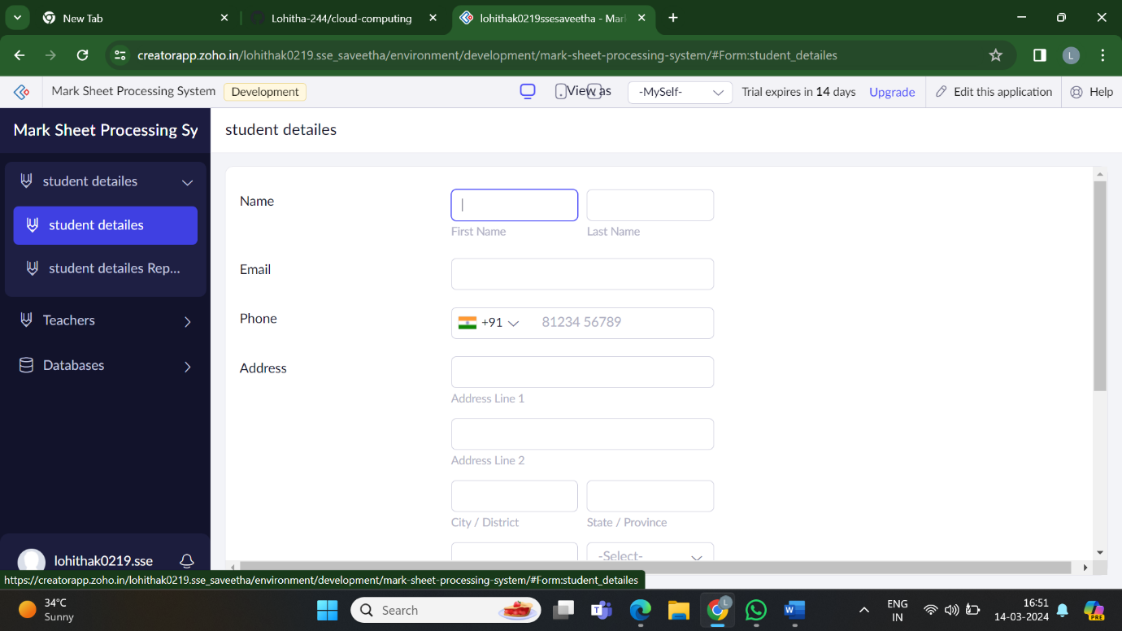

2.create teacher application form

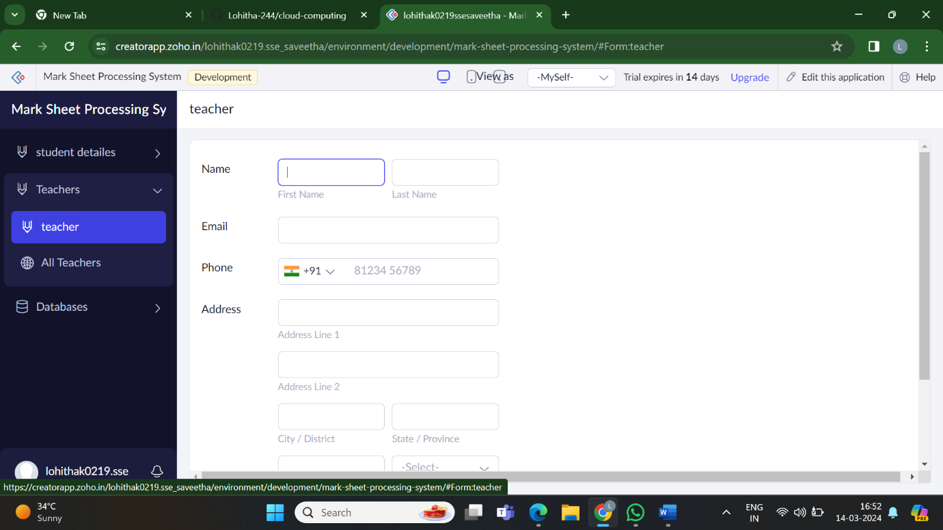

3.create data base application form

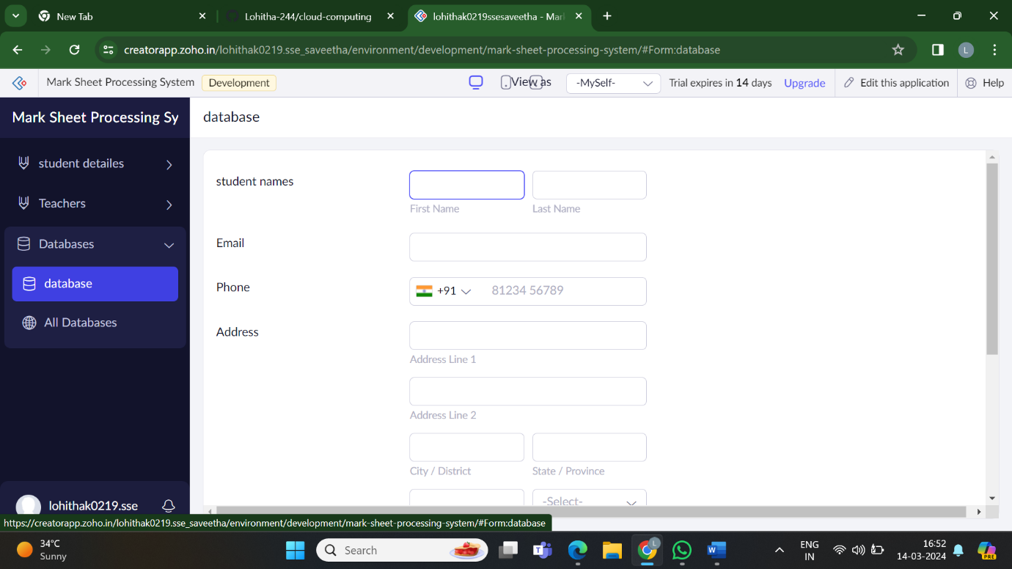

4.shows the result of the data base obtained by the users

